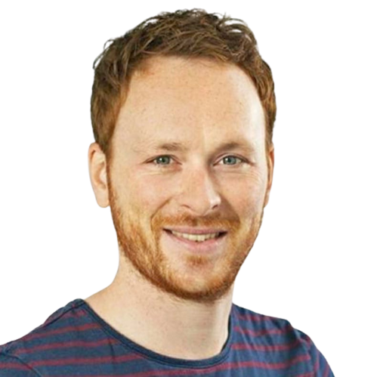
Bart Wagener, MA Sr. SEO-specialist
Matsmanzoom 31 Born: 13-10-1984
1541 SP, Koog ad Zaan Nationality: Dutch
06 54 72 10 59 bartwagener@gmail.com

Profile
I am a passionate SEO-professional always looking to test myself by engaging with increasingly complicated SEO-challenges. It’s what gives me energy. E.g; for Action I initiated a machine learning pilot for product description pages (before ChatGPT was a thing). For FedEx we are building a programmatic content creation process to capitalize on keywords like shipping to {city/country}

I love sharing my passion. I have been lucky to do so as a trainer for colleagues and clients but also as an internal stakeholder.

Experience
Sr. SEO-specialist Fedex.com - 01/07/2021 - present
Building processes is the name of the game at FedEx. There are no processes for SEO and very little awareness of SEO best practices.
- Using an existing platform called the marketing academy, we spread SEO awareness across the organization via webinars and workshops
- Global keyword data was not available. Localizing an English master with vendor (Acolad) for largest markets EU, MEISA, LAC and APAC
- Creating content creation process for C2C (city to city / country to country) across EU. Goal: turn it into programmatic (AI augmented) content generation "machine" globally
- Examples
  - Onboarding enterprise level tooling and vendors such as Conductor and Acolad while keeping Screaming Frog because it's simply the best
  - Founding TeSSC (technical SEO steering committee, global remit) to push stories through the ART
    - Fixing XML-sitemaps with poorly implemented Ahreflang tags
    - PageSpeed optimizations
  - Improving local visibility via Yext. Mainly aligning source systems.

Sr. SEO-specialist Action.com - 01/12/2019 - 31/6/2021
As the only SEO at Action maximizing impact is a fun challenge. I do this by building bridges across departments. I use what was there already and add to it.
- Agile way of working for technical optimization
- Trainer and stakeholder for the copywriting team. Working towards agile marketing.
- Examples
  - Leveraging machine learning for product page optimization
  - Server Side Rendering (SSR) for maximal discoverability for a VueJS framework.
  - Maintaining 1500+ Google My Business locations (via Uberall)
  - Turning URL and category selection from inside-out to outside-in (taxonomy)
  - Implementing search and merchandising via Algolia (faceted search)

Sr. SEO-consultant SDIM 01/12/2015 - 01/10/ 2019
- Sr. SEO-consultant. Full stack-SEO. Content, technique and authority
- SEO-trainer (ex- and internal training sessions, creating my own products)
- Content marketing
- Sales experience
- Some clients: Anicura.nl, Mollie (interim), XXL-nutrition, BMN.nl, Hearst Media (Quest, Vogue and Men’s Health among other titles).

2012 - 2015: social media consultant & trainer (Buzzcapture, acquired - Obi4Wan), freelance SEO-copywriter and front end developer, online marketeer (Hotelprofessionals)

Education
Master and Bachelor International Relations (IB/IO), 2004-2010, faculty of Arts, Rijksuniversiteit Groningen
Specialized in international (war) ethics, causes of political violence and (Dutch) foreign aid.

Skills
SEO | ◉◉◉◉◉ |  | HTML | ◉◉◉◉◉
Content Marketing | ◉◉◉◉◉ |  | CSS | ◉◉◉◉◉
Google Analytics | ◉◉◉◉◉ |  | JavaScript | ◉◉◉◉◉
Google Tag Manager | ◉◉◉◉◉ |  | Python | ◉◉◉◉◉
Screaming Frog | ◉◉◉◉◉ |  | Excel | ◉◉◉◉◉
DeepCrawl | ◉◉◉◉◉ |  | WordPress | ◉◉◉◉◉
SEMRush | ◉◉◉◉◉ |  | DataStudio | ◉◉◉◉◉
Ahrefs | ◉◉◉◉◉ |  | MySQL | ◉◉◉◉◉
Dutch | ◉◉◉◉◉ |  | Accountmanagement | ◉◉◉◉◉
English | ◉◉◉◉◉ |  | Presenting /speaker | ◉◉◉◉◉
Spanish | ◉◉◉◉◉ |  | Trainer | ◉◉◉◉◉

